## 读后续写速成:“五点爆破”法

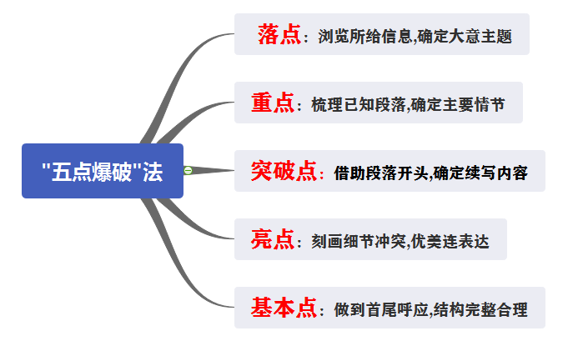

# 五步写作法流程示例

阅读下面短文，根据所给情节进行续写，使之构成一个完整的故事。

One weekend in July, Jane and her husband, Tom, had driven three hours to camp overnight by a lake in the forest. Unfortunately, on the way an unpleasant subject came up and they started to quarrel. By the time they reached the lake, Jane was so angry that she said to Tom, “I’m going to find a better spot for us to camp” and walked away.

With no path to follow, Jane just walked on for quite a long time. After she had climbed to a high place, she turned around, hoping to see the lake. To her surprise, she saw nothing but forest and, far beyond, a snowcapped mountain top. She suddenly realized that she was lost.

“Tom!” she cried. “Help!”

No reply. If only she had not left her mobile phone in that bag with Tom. Jane kept moving, but the farther she walked, the more confused she became. As night was beginning to fall, Jane was so tired that she had to stop for the night. Lying awake in the dark, Jane wanted very much to be with Tom and her family. She wanted to hold him and tell him how much she loved him.

Jane rose at the break of day, hungry and thirsty. She could hear water trickling (滴落) somewhere at a distance. Quickly she followed the sound to a stream. To her great joy, she also saw some berry bushes. She drank and ate a few berries. Never in her life had she tasted anything better. Feeling stronger now, Jane began to walk along the stream and hope it would lead her to the lake.

As she picked her way carefully along the stream, Jane heard a helicopter. Is that for me? Unfortunately, the trees made it impossible for people to see her from above. A few minutes later, another helicopter flew overhead. Jane took off her yellow blouse, thinking that she should go to an open area and flag them if they came back again.

But no more helicopters came and it was dark. _________________________________

It was daybreak when Jane woke up. _________________________________________

## Step1 落点：浏览所给信息,确定大意主题

|  |  |
| --- | --- |
| **who** | Jane,Tom |
| **what** | Jane was lost |
| **where** | In a forest |
| **when** | One weekend in July |
| **why** | A quarrel with Tom,her husband |
| **文章大意** | Jane was lost in the forest for three days and survived in the end |
| **表达主题** | Jane learned how to control emotions and deal with conflicts |

## Step2 重点：梳理已知段落,确定主要情节

|  |  |  |
| --- | --- | --- |
| **主要情节** | beginning | …started to quarrel…was lost |
| development | …kept moving…had to stop for the night…  Rose at the break of day…  Began to walk along the stream and hope… |
| climax(高潮) | heard a helicopter |
| ending | 待定 |

## step3突破点：借助段落开头,确定续写内容

|  |  |  |
| --- | --- | --- |
| **研读续写段落的开头语** | Para.1 | But no more helicopters came and it was getting dark again.  (切入点)Jane是如何熬过这个夜晚的？ |
| 1. How did Jane feel then? 2. How did Jane struggle through the night? 3. Did she fall asleep and what did she think of? |
| Para.2 | It was daybreak when Jane woke up?  (切入点)昨晚Jane 没有被救，今天会发生什么？ |
| 1. Was Jane rescued and who rescued Jane? 2. How was she rescued and how did she feel then? |
| 续写内容 | Para.1 | Jane是如何熬过那一夜晚的 |
| Para.2 | Jane是如何获救的 |

## Step4 亮点：刻画细节冲突,优美连表达

|  |  |
| --- | --- |
| **刻画细节冲突** | |
| 添加细节 | Jane在当晚和次日的动作，语言，心理描写以及对周围环境的描写。 |
| **营造冲突** | 1. **扩大Jane在夜晚内心的冲突(后悔与丈夫吵架)** 2. **渲染Jane当晚与次日与环境之间的冲突(当晚’’恶劣’’环境与内心无助和恐惧的冲突；次日让直升机发现自己的困难与渴望被救的冲突)** |

优美连贯表达

But no more helicopters came and it was getting dark again.In the dreadful darkness,①____________________________________________________________________

(一切都像准备好发动攻击的野兽)[明喻+过去分词作定语]

②_______________________________(又累又怕)[双形容词作状语]，Jane was rooted to spot,unable to utter a word.’’



③____________________________________________________

(如果我没有和汤姆吵架，我现在就不会被困在这里了)[虚拟语气]，”She thought of herself

④__________________________________________________(后悔的泪水模糊了她的眼睛)[with 的复合结构].

⑤________________________________(被恐惧包围着)[过去分词作状语]，Jane abandoned herself to despair and fell asleep.“Tom,is that you?”

She murmured.“Tom,help!”In her dream,⑥_____________________________________

(她看见一位男士张开双臂)[现在分词作宾补]towards her at a distance.

It was daybreak when Jane woke up.⑦__________________________(尽管很沮丧)[省略结构]，Jane decided to continue forcing her way ahead.However,she found it hard to find a way out,⑧____________________________________________(这再次让她绝望)

[定语从句].Fortunately,a helicopter flew overhead just at that moment.

⑨__________________________________________________(Jane太激动了，她立刻冲到岩石边)[倒装结构]and climbed onto it eagerly.

⑩______________________________________(眼里闪耀着希望的光芒)[独立主格结构]，she waved her yellow blouse madly to the helicopter,(11)_________________________________(大声呼救)[现在分词短语作伴随状语].To her great joy,the helicopter spotted her and came to her help.

(12)______________________________________(当团聚的时候)[省略结构]，Jane and her husband hugged each other tightly in the warmth light of the rising sun.

## Step5基本点：做到首尾呼应,结构完整合理

提升点：为了做到首尾呼应，使文章结构更加完整，考生可以在第二段的结尾回扣文章开头Jane与丈夫的争吵和冲突，充分体现本次经历后二人的感受。

**优秀范文**

But no more helicopters came and it was getting dark again. Immediately, an absolute darkness ruled the forest. Jane, exhausted and scared, lay down near a stone, missing her family at a distance. All the fantastic memory crowded in and she couldn't help crying, "Hadn't I quarreled with Tom, walked away and climbed to the high place, I wouldn't be trapped in this awful place, confronted with the danger of dying." She regretted with endless anxiety, and then became asleep with shining tears in her eyes.

It was daybreak when Jane woke up. Weak as she was, she struggled to her feet, continuing searching for assistance. To her great joy, a helicopter was flying overhead again and again. Eager and excited, she flagged her yellow blouse and spared no effort to yell so as to attract others'attention. Fortunately, she was eventually noticed and brought into the helicopter. There, she saw her husband, a man staring at her, wearing an expression of relief. As tightly as possible, she hugged him and was too thrilled to say anything. Besides, they agreed never to quarrel again, determining to live the life to the fullest.

【解析】

首先，在逻辑上，要做到了合理合情：起初，主人公身陷森林，内心充满了悔恨，在面对困难时焦虑、畏惧；之后，主人公努力求生，最终获救，并且领悟到了一定的人生道理。纵观整个故事，情节发展不仅符合两段给出的开头所限定的情景要求，而且还设置了一定的悬念，增强了故事的可读性。

文章第一句 "an absolute darkness ruled the forest" 中， "rule" 一词就使用了拟人的修辞手法，让森林阴森黑暗的一面展露无遗，同时描绘出主人公身处绝境的紧迫性。在 "Eager and excited, she flagged her yellow blouse…" 一句中，直接将情绪形容词放在句首，使用了非谓语动词的语法，表达精练。

此外， "There, she saw her husband, a man staring at her, wearing an expression of relief." 一句中，使用了几个短句，却包含了两处非谓语动词语法，同时活用了 "wear" 一词，把两个人相见时的场景生动地描绘了出来。

【词汇拓展】

1) 表示并列关系的过渡词：and, as well as, or ，Not only … but also

2) 表示转折关系的过渡词：but, yet, however , although , though …

3) 表示时间关系的过渡词：first, second, third, and then, finally, after, before, after a few days, at last, at that time, later, in the past, immediately, in the meanwhile, when, while, then, after that …